**HTML Validation Check  
  
Index.html  
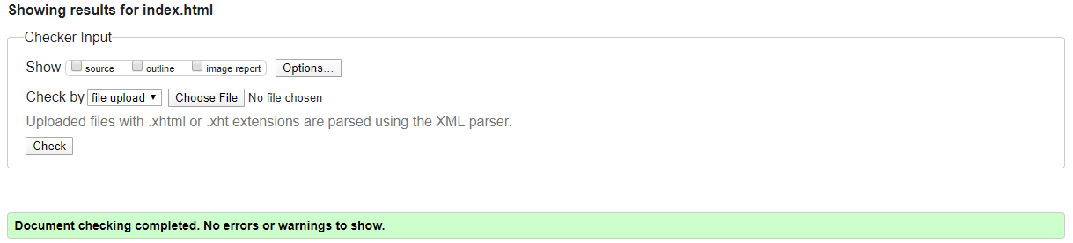**

**Board.html**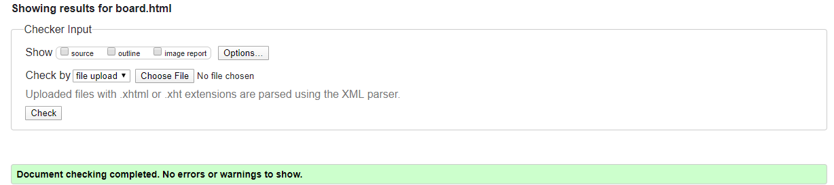

**Training.html**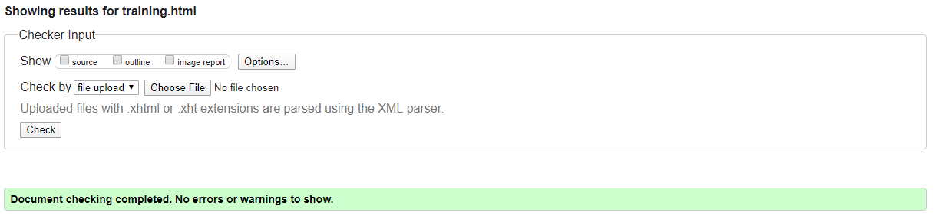

**CSS Validation Check**

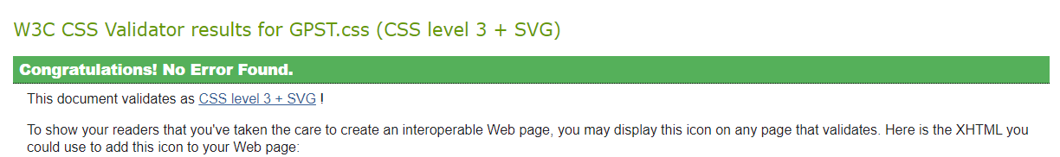

[**https://lab5.jordanwentland.com**](https://lab5.jordanwentland.com)